Identification and Visualization of WWW User Types
Using Multi-Modal Clustering

Hinrich Schuetze, James Pitkow, Jun Li, Ed Chi, Peter Pirolli
Xerox Palo Alto Research Center
3333 Coyote Hill Road
Palo Alto, CA 94304 USA
{schuetze,pitkow,li,chi,pirolli}@parc.xerox.com

ABSTRACT
Understanding the user population of a World Wide Web site is a challenging task. Limitations on data collection and the sheer size of Web ecologies, makes analysis of individual users impractical. Traditional approaches that attempt to alleviate this problem are clustering and information visualization. In this paper, we present a novel method of clustering that takes into account multiple sources of information about users to generate user clusters. Additionally, a new method and information visualization system is described with facilitates the understanding and analysis of user clusters. We show that several important question about information content and Web site design can be answered by using multi-modal clustering an the visualization system.

Keywords
Clustering, multiple modalities, information visualization, WWW, logfile analysis

INTRODUCTION
In the physical world, there is usually some amount of useful information available to characterize the users of a system. This information can come from the context in which the system is used (e.g., users of action video games tend to be young), from the context in which the system is acquired (e.g., demographic information that can be derived from a credit card transaction), or from explicitly asking the user for a self-characterization (e.g., a questionnaire one fills out in return for getting access to the public library). The information gathered facilitates the understanding and iterative design of interactive systems.
On the World Wide Web, such detailed information is typically not known about the users of Web sites. Possible exceptions include sites that involve commercial transactions, that require user registration, and that use advertising networks like Double Click. A user can visit a Web site from any geographical location disguised under the auspices of any domain name, making a priori characterization quite difficult. To further complicate the matter, the size of the user population on many Web sites is large and the interactions of users can be complex because they follow long paths through Web sites or use Common Gateway Interface (CGI) scripts. These factors make it challenging to understand the relationships between the users and the information contained within a Web site.

COPYRIGHT NOTICE

Fortunately, although direct information about the user of a Web site may not be readily obtainable, indirect user characterizations are possible given the set of objects that users interact with. Information that is available about Web objects includes:
- content—the text on a Web page,
- usage—record of user interactions with Web pages,
- topology—the structure of the Web site containing hyperlinks pointing to and from the Web pages,
- URL—the Uniform Resource Locator (name) of the object (e.g., URLs of home pages often contain the tilde mark).
In this paper, we extend our previous work [1, 2] by developing a new methodology for identifying, characterizing, and visualizing types of users based on multi-modal clustering. Multi-modal clustering is a clustering technique that combines all accessible information about users (information on content, topology, usage (data sources we refer to as CUT), and the URLs accessed) instead of just looking at one type (or modality) of information. This classification of users into types is useful for improving the Web site design so that each user type can easily access desired information. This techniques of user stratification and aggregation is also useful for user modeling, which can aid in the development of new content and in increasing the usage of a site by making it more effective.
We find that the biological metaphor of an information ecology provides a useful structure to frame the analysis and understanding of user behavior and information foraging [3][Pirolli, 1998 #5]. In this paper, we show that some user "species" look for information in the manner that some animals graze for food by systematically scouring a site for interesting pages. Other users swoop down on a single page and leave immediately thereafter. We characterize the complex pattern of relationships between user types and the document environment. User clusters are difficult to understand and visualize because there is not predefined structure like a hierarchy to order the results. To help alleviate this shortcoming, we extend our previous work on Disk Trees[4] by visualizing the pages that are most typical of a user type. We also characterize each user type by the content, the links and the URL path elements that are most typical of that segment of users.

Testbed Data
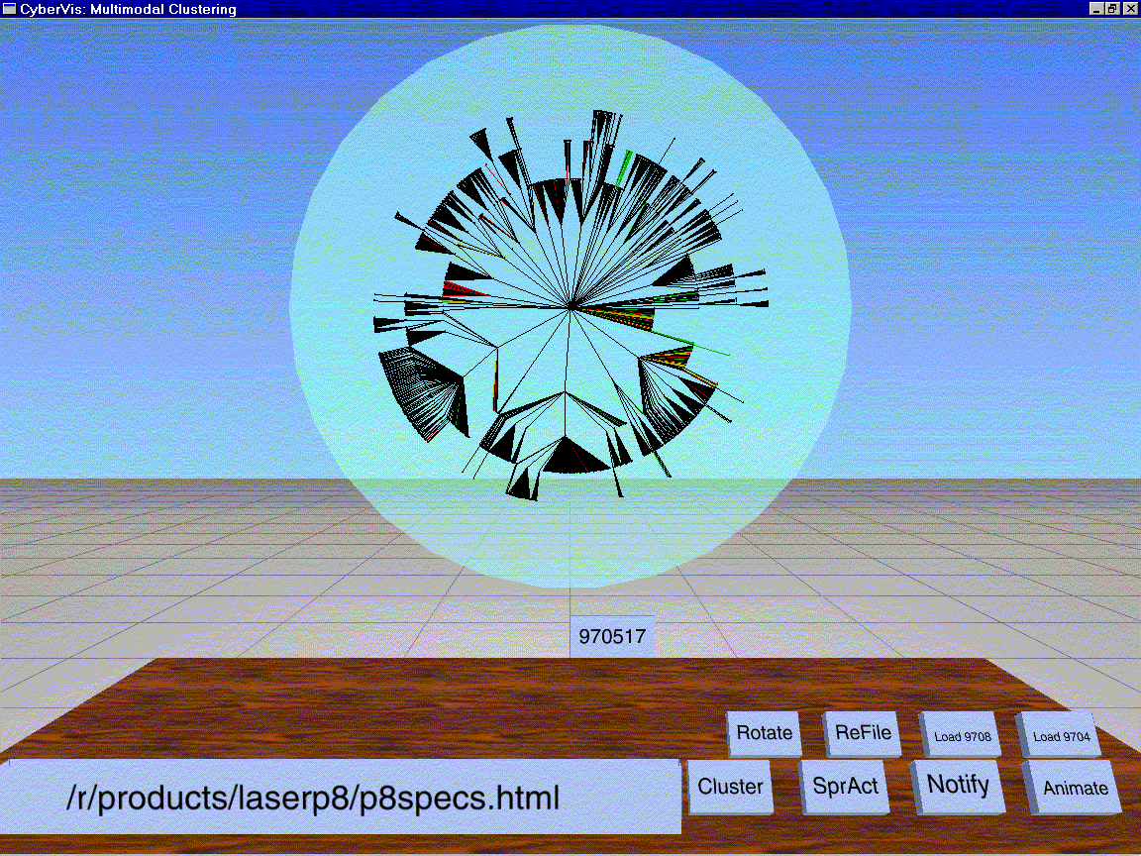
The testbed used for this paper consists of a complete snapshot of the Xerox Web site (http://www.xerox.com) on May 17, 1998. The entire day's usage information for over 6,000 users was collected. Additionally, the entire content and hyperlink topology was extracted. The site consists of over 6,000 HTML pages and 8,000 non-HTML pages. Using these data, we will now show how multi-modal clustering can answer questions like the following:
Figure 1. Disk Tree showing the micro level analysis of user groups within the Xerox Web site during May 1998. These are the groups interested in the Laser Printer P8 product offering.
- What are the different types of users that visit the Xerox Web site?
- What are the information-seeking behaviors of different user types (e.g., grazing vs. focussed hunting)?
- Is there a difference between internal and external users, i.e., those accessing the site from within the Xerox domain vs. those accessing the sites from outside the Xerox domain?
- How could one redesign the Web site to better serve users and promote more effective use of the Web site in general?

MULTI-MODAL CLUSTERING
With respect to other forms of statistical techniques, clustering is a relatively new form of data analysis. Two main methods of clustering exist: 1) agglomerative and 2) partitioning. Both methods assume that some distance metric is computable. With agglomerative clustering, creates a hierarchy by first merging individual elements whose distances are the smallest and then recursively merging clusters until all the elements and clusters are merged. Partitioning algorithms start with a number of random seeds and then go through several iterations of assignments of elements to clusters and re-computation of cluster centers or centroids [5]. IT is important to note that both types of clustering only apply to a single source of data/information, i.e., clustering on statewide voting behaviors.
We propose a new method of user clustering by defining an aggregate measure of similarity between users that combines all information available across all users. We refer to disparate types of information as "modalities". Multi-modal clustering hence is the grouping of objects that have data from several modalities associated with them. With respect to this paper and the Xerox Web site users, the modalities we employ are content, in-links, outlinks, usage, and URLs.
In order to apply clustering to multi-modal objects, we need to define a similarity metric between users that merges information from all modalities. To this end, we define a uniform data model for all modalities and embed each modality into R^{n}. We use a method similar to the method that is used to embed content (text) into the vector space model [6].
In the vector space model, each text document d is embedded into R^{n_c} where n_c is the total number of words in the text repository under consideration. The embedding phi_c is defined as:
phi_c(d)_i = 0 if word i does not occur in d
phi_c(d)_i = weight(d,r,i) if word i occurs in d
where phi_c is a function mapping from text documents into R^{n_c}, phi_c(d)_i is the i^{th} component of vector phi(d) and weight(d,r,i) is a weight for term i in document d that depends on the document, the repository (for example, for document frequency of the word) and the word itself.
In order to compute similarity measures for other modalities, we embed them into R^{n} in an analogous way. For example, we embed the outlink modality into R^{n_o} where n_o is the number of pages that a page in our collection points to. We define an embedding phi_o as follows:
phi_o(d)_i = 0 if page d contains no hyperlink pointing to page i
phi_o(d)_i = weight(d,r,i) if page d contains a hyperlink pointing to page i
where weight(d,r,i) is a weight depending, for example, on how many pointers to i there are on page d, and how many other pages in the repository r point to i. This assumes that each page that is pointed to by a page in our collection has an index i. Note that for many dimensions i in the space, the corresponding page will not be part of the collection. For example, if our collection is the Xerox Web site and it contains a pointer to a news article on www.nytimes.com, then the corresponding article on www.nytimes.com is not a part of the collection.
We can define a similar embedding for in-links. URL paths (paths are first parsed into words (for example, "www.msn.com/search" becomes "www.msn.com" and "search") and then treated as text and mapped into a space R_n_u where n_u is the total number of path elements that occur.
Representations of users in content, in-link, outlink and URL modality are then derived by collecting all the pages that the user has accessed and computing the average or centroid in the appropriate modality.
Usage logs are mapped directly into R_n_p, where p is the number of pages on the Web site and no averaging is necessary. A user is then represented in R_n_p as a vector that has a value of one for pages that the user accessed and a value of zero for pages that the user did not access.
Once we have defined embeddings for each modality, we can use the standard cosine similarity measure to compute the similarity between two users u1 and u2 for a particular modality z:
sim_z (u1^{z},u2^{z}) = (sum_i u1^{z_i} u2^{z_i})/(sum_i u1^{z_I}^²) (sum_i u2^{z_i}^²)
where u1^{z} and u2^{z} are the embeddings of the two documents for modality z.
We compute the multi-modal similarity of p₁ and p₂ as the sum of the individual similarities:
sim_mm (p₁,p₂) = sum_z sim_z (d1^{z},d2²)
Now that we have defined a similarity metric for multi-modal objects, we can use a standard clustering algorithm. We use k-means clustering, which is a partitioning method [5]. K-means starts with k randomly selected users as cluster centers. Users are assigned to the closest cluster center (the center they have the highest similarity with). Then cluster centers are recomputed as the mean of their members. The process of (re)assignment of objects and re-computation of means is repeated several times until it converges. The number k of clusters is a parameter of the method. In our analysis used in this paper, we varied the value of k, using values of 20 and 50.
The result of multi-model clustering is a textual listing of the dimensions that are most characteristic of a cluster for each modality. For example, if the cluster is about the Xerox product Home Center, then a salient dimension for the content modality is the phrase "Home Center". Given that for the Xerox Web site, twenty to fifty clusters were produced each containing hundreds of users, the task of identifying, comparing, and evaluating the cluster results in textual form was daunting. This limitation forced us to turn to information visualization techniques for a solution.

SYSTEM DESCRIPTION
To understand the results of multi-modal user clustering, we extended the CyberVis [[4] developed for Web ecology analyis. The modified system consists of:
- the mapper, which maps modal information into real-value vectors,
- the clustering program, which clusters a set of users, and
- the CyberVis visualization system, which handles interactive data visualization of Web sites.
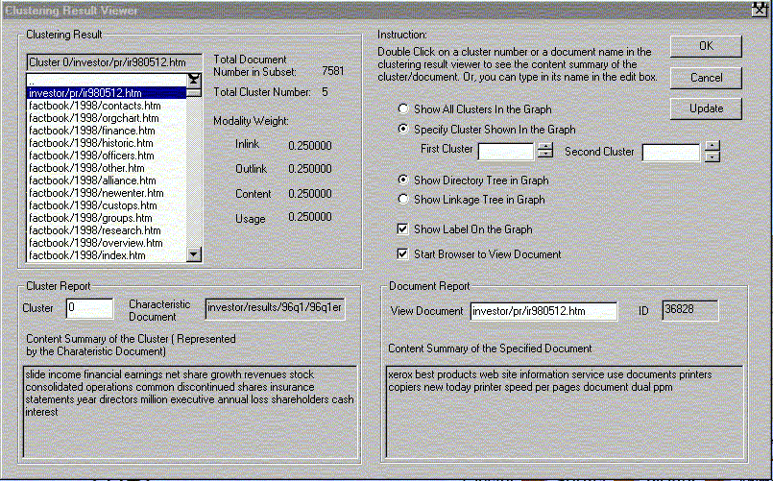
CyberVis analyzes the directory structure of a Web site and constructs a Disk Tree as shown in Figure 1. Each directory corresponds to one node in the tree with all subdirectories and files in the directory being represented as children of the node. Layout of the tree is performed on a Breadth-First basis. The Disk Tree in Figure 1 shows the Xerox Web site, starting from the Xerox Splash Page, with subsequent directories being depicted as concentric rings extending from the center of the disk. This produces as asymmetric disk, which reveals the heterogeneous allocation of files and directories in the Xerox site.
Figure 2. Dialog box that controls the user interaction and specification of multi-modal clusters. Information about the clusters including representative content words and the characteristic documents are also presented.
Via a dialog box interface shown in Figure 2., the user can interactively specify which clusters to display (currently limited to one or two clusters simultaneously). The dialog box displays a textual representation of the members of each cluster. For each cluster member, the weights of each modality are listed. For example, in Figure 2 /investor/pr/ir980512.html is a member of cluster 0. The in-link, out-link, content, and usage modalities are equally weighted (25% each). The "Cluster Report" contains the most characteristic keywords across all documents for the user cluster. This enables quick access to a high level abstraction of this modality while simultaneously viewing other properties. The "Document Report" provides the URL and a textual summary of the most characteristic document in the cluster. Our experience with multi-dimensional clustering shows that in some cases, the Cluster Report is the best characterization of the cluster and in other cases, the Document Report provides the best characterization. Our interaction with the system was greatly facilitated by being able to readily access to summaries of both the entire cluster and the most representative document.
Clusters are visualized by coloring all arcs that correspond to members of the cluster in one color. Additionally, the systems allow for the visualization of multiple membership. For these cases, multiple membership is simply indicated by mixing the colors of all clusters that the page belongs to.
Our motivation for showing pages instead of showing users directly is that users are not organized structurally and hierarchically the same way pages are so that the direct visualization of users is difficult. A technical problem then is how to show user clusters in a web page-based visualization. We solve this problem by computing the probability that a particular page will be accessed if we pick a random user from a cluster. We compute this probability as follows.
$$P(\text{page}|{\text{user}}_{{\text{type}}_{t}})=\sum_{{\text{users}}_{{\text{ot}}_{{\text{type}}_{t}}}}{P(\text{page}|u)}$$
P(page|u) is simply computed as the relative frequency. For example, if a user accesses three pages, then each of them will have a probability P(page|u) of 1/3.

SCENARIOS

What types of users (macro-level)?
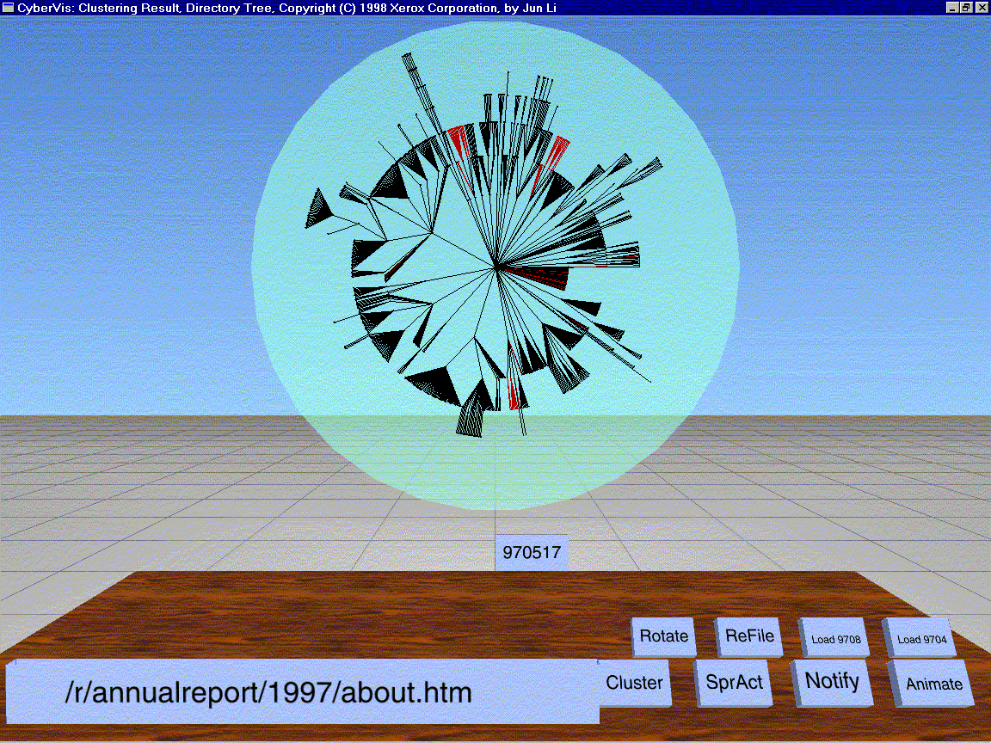
In order to analyze the user population on the macro level, we clustered all 6400 users into 20 clusters. 9 clusters correspond to product categories: pagis scanning, copiers, xsoft software, xerox software library (for downloading pages), home and desktop products, textbridge for windows. 7 clusters correspond to users that mainly access a single page, for example the index of drivers or the xerox home page. One cluster contains visitors who access employment information. One cluster contains investors and other visitors who are interested in press releases and other news about xerox. 2 clusters are mixed, containing users that do not fit well into any of the other categories.
Figure 3. Disk Tree showing utility of multi-modal clustering for Web site design. The investor clusters is displayed in red. Interestingly, pages within the cluster occur in several portions of the directory structure, including the Annual Report and the Xerox 1998 Fact Book.
One surprising finding is that there is only one investor cluster (and even this cluster contains many visitors who are interested in news in general, not only as it relates to investing). Note there are many visitors who browse through a large number of pages and cannot be counted as investors although they also access the index page of the investing sub-tree among other pages. Such users are not assigned to the investing cluster by the clustering routine. Clustering thus helps in arriving at an accurate picture of how many investors access the site.

What types of users (micro-level)?
On May 15, 1998, Xerox announced a new printer, the laser printer P8. Recall that our analysis is for the logs that were collected two days later, on May 17. We were interested in characterizing the users who look up information about the P8 (presumably after reading or hearing about its launch).
The results are shown in Figure 1. The figure shows two of the clusters (in red and green) with the highest activation for the P8 pages (that is, users from these two clusters had pages with the highest values for P(page|u)). The red cluster has the most concentrated activity in the upper left corner, corresponding to the news sub-hierarchy of the site. These are users who are interested in general information about Xerox and its printer program (e.g., because they are competitors or because they want to determine whether it is a good time to invest in Xerox). The green cluster has its most concentrated activity in the upper right corner. This is the party of the sub-hierarchy where drivers and other specific technical information is located. So these are users who are contemplating buying the P8 and who want to know whether there is an appropriate driver available and what the exact technical specifications of the P8 are.
These two examples illustrate how multi-modal clustering can be used for a characterization of the user population both on the micro level and on the macro level.

What types of information seeking behaviors?
As mentioned above, a striking feature of several clusters is that they essentially consist of users that access only one page. Examples of such user clusters include: the cluster that only accesses the Xerox home page; the cluster that only accesses the page for requesting a trial version of textbridge pro 98 (an ocr program); and the cluster that only accesses the page that describes how to upgrade an older version of textbridge for Word 97.
These users have a clearly defined information need and are probably following a link from outside. Once they have the information they need (for example, Xerox' stock price on the Xerox home page), they leave immediately.
Other clusters are characterized by grazing behavior, a much more amphorphous information need that is gradually satisifed as the user browses through a large number of pages. One example is the cluster of users browsing the subhierarchy called the Document Home Centre which has information on smaller devices, appropriate for small office and home office. These users come to the Xerox website to educate themselves about the range of products available, a process that requires looking at a relative wide spectrum of information.

Internal vs. external users
How different are internal and external users (users visiting the site from inside vs outside xerox)? To answer this question we did a more fine-grained multi-modal clustering into 50 clusters of all users. We then computed the percentage of xerox users in each of these 50 clusters. We had expected large differences between internal and external users. However, to our surprise, most clusters had a proportion of xerox users that did not deviate siginficantly from 9 pct (which is the overall proportion of xerox users in our data). For example, for many product subhierarchies, xerox visitors are representative of the large user population. The reason is that many xerox employees buy and use xerox products at home and in the workplace.
Still, there were a few significant differences. The cluster of users looking at information about the 2.0 release of Pagis Pro (a scanning product announced on the morning of May 18, which is still in our log) does not contain a single Xerox user, probably because these users are looking at internal information about Pagis Pro (which is distributed via an internal newsletter).
Conversely, a larger proportion of Xerox users only accesses the Xerox home page without further access to any other page (1/3 of the users in the home-page only cluster are Xerox employees). The reason is probably that a large proportion of Xerox users have their default initial location set to the xerox home page, but browse on to another location once their browser has been launched.

How could one redesign the website?
Multi-modal clustering is also useful for improving the design of a website. Figure 3 shows a cluster of investors from the 50-cluster clustering. There are two areas of strong activity in the upper half of the figure (in red). One corresponds to the sub-hierarchy "annualreport", the other corresponds to the sub-hierarchy "factbook". The fact that many investors look at both suggests that the hierarchy should be reorganized so that these two sub-hierarchies are located together.

RELATED WORK
[7] also address the problem of clustering users. However, they only use one modality (page accesses) and they do not develop a visualization. They also had to exclude a part of the data from analysis because mono-modal clustering is not robust enough for users with a small number of page accesses. Such users are not a problem in multi-modal clustering and we were able to include them in the above analysis.
An example may illustrate why multi-modal clustering is a solution for data sparseness. Suppose a user only accesses one page, a description of laser printer P8, and that nobody else accesses this page. In a mono-modal approach, this user cannot be assigned to a cluster in a motivated way since there is no overt similarity between this user and any other user. However, in a multi-modal approach, the user will be represented on other modalities, in addition to the page modality. For example, the content description will contain words like "laser" and "printer". For this reason, the user will be similar to other users that access laser printer information and s/he can be assigned to an appropriate cluster.

FUTURE WORK
In an increasingly complex world, there is a growing number of problems in which objects have disparate types of information associated with them. We therefore believe that multi-modal clustering is an important methodology for designing other types of systems in which users interact with a large number of objects with complex relationships to each other. One such example are multimedia objects like images. Images are also represented by disparate types of information: color histograms, texture information, positional information of embedded objects, and possibly text from manual indexing. The methodology developed here can be easily transferred to the clustering of multi-media objects.

CONCLUSION
The WWW poses an interesting challenge to answering the main principle of Human Computer Interaction—Know thy User. In this paper we have presented a novel clustering algorithm called multi-modal clustering that leverages multiple sources of data to stratify users into meaningful groups. We have also presented our initial attempt at alleviating the problem of understanding large multi-membership clusters by extending the work on a prior visualization system. Based upon results of multi-modal clusters and the visualization system, difficult questions about the relationship between users and Web sites can be answered. While research into this area is by no means complete, we have provided a solid algorithmic and systems foundation for the continued exploration and analysis of one of the most interesting information ecologies, the World Wide Web.

REFERENCES

1. Pirolli, P., J. Pitkow, and R. Rao. Silk from a sow's ear: Extracting usable structures from the web. in Conference on Human Factors in Computing Systems, CHI '96. 1996. Vancouver, Canada.
2. Pitkow, J. and P. Pirolli. Life, death, and lawfulness on the electronic frontier. in Conference on Human Factors in Computing Systems, CHI '97. 1997. Atlanta, GA: Association for Computing MAchinery.
3. Pirolli, P. and S.K. Card. Information foraging in information access environments. in CHI '95, ACM Conference on Human Factors in Software. 1995. New York: ACM.
4. Chi, E., et al. Visualizing the evolution of web ecologies. in Conference on Human Factors in Computing Systems, CHI '98. 1998. Los Angeles: ACM.
5. Duda, R. and P. Hart, Pattern classification and scene analysis. 1973, New York: Wiley.
6. Salton, G. and M. McGill, Introduction to Modern Information Retrieval. 1983, New York: McGraw-Hill.
7. Yan, T.W., et al. From User Access Patterns to Dynamic Hypertext Linking. in Fifth International World Wide Web Conference. 1996. Paris, France.

Unfortunately, we were not able to reproduce the Figures in a manner that accurately reflects the display. As such, the resolution and color displayed in the figures of this paper as less than ideal. We intend to fix this problem in the final version of the paper by using enlarged figures with better resolution.

